VS 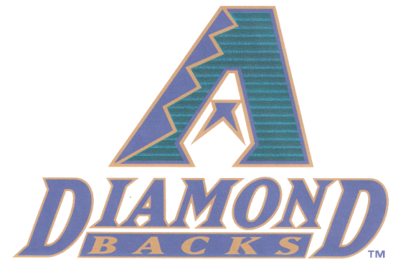

TAKE ME OUT TO THE BALL GAME
Friday, July 19, 2013 7:15 PM
AT & T Park San Francisco

Stay after the annual conference to join other CACEO members attending the MLB game Friday night between the San Francisco Giants and Arizona Diamond Backs. I will secure group tickets if you are interested in attending. Ticket price depends on how many will be going but plan on $19-$27 outfield seating. We need a minimum of 18 people for advance group tickets; you will be notified if minimum was not reached. You are responsible for your own transportation to and from AT & T Park. Public transportation is available near the Sofitel Hotel, information will be provided to those who are interested.
If you are interested and would like tickets please complete and email form below to cckeller52@gmail.com no later than June 19, 2013.

________________________________________________________________________________________
YES SIGN ME UP FOR GIANTS vs. DIAMONDBACK Tickets
Name ____________________________________________________________________
# Of Tickets: __________________

I understand tickets must be paid for in advance and once purchased there are no returns, refunds or exchanges and that I am responsible for my own transportation to and from the ball park.
Initials: __________

